Bexleyheath & Crayford Conservative Association

ST MICHAEL’S SUPPER EVENING
with Guest Speaker

JACKIE DOYLE-PRICE MP
for Thurrock
Assistant Government Whip

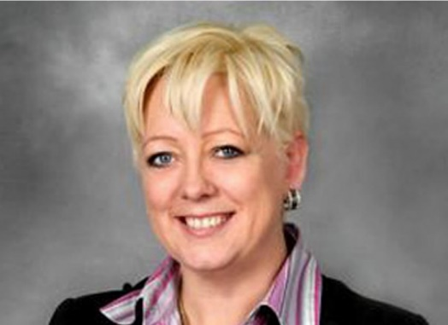

Thursday 2nd March 2017
Time: 7.00pm for 7.30pm

Bexleyheath Conservative Club
151 Broadway, Bexleyheath DA6 7EZ

Tickets: £15.00 Raffle

I would like …………tickets to the Supper Evening and
enclose a cheque for £……………
have made a transfer for £........... to: Sort Code: 20-06-72
A/C NO: 90172472
Name……………………………………………………………………………………

Address ………………………………………………………………………………..

……………………………………………………………………………………………..

Email…………………………………………………………………………………….

Phone No.……………………………………………………………………………

Other Guests:
Guest 2 Name……………………………………………………………………….

Guest 3 Name……………………………………………………………………….

Guest 4 Name……………………………………………………………………….

Guest 5 Name……………………………………………………………………….

Cheques should be made payable and sent to BCCA.
Please email the office if you pay by bank transfer.

Post : 17, Church Road, Bexleyheath, Kent. DA7 4DD
Telephone : 020 8303 4695
Email : bexleyheath-crayford@tory.org

Jackie Doyle-Price was educated at Notre Dame High School, Sheffield and studied economics at University College, Durham. After graduating she worked for the Sheffield Enterprise Agency and for South Yorkshire Police. She later became Parliamentary Officer at The City of London and then Private Secretary to the Lord Mayor of the City of London before working as a consumer advocate for the Financial Services Authority.

Jackie was elected as the MP for Thurrock in 2010 and re-elected in 2015.

In June 2010, Jackie was appointed to the House of Commons Public Accounts Committee which is responsible for scrutinising Government spending and whether it is delivering value for money. In May 2012 she was elected Chairman of the All Party Gurkha Welfare Group.

Following the 2015 General Election Jackie was appointed as an Assistant Whip.

